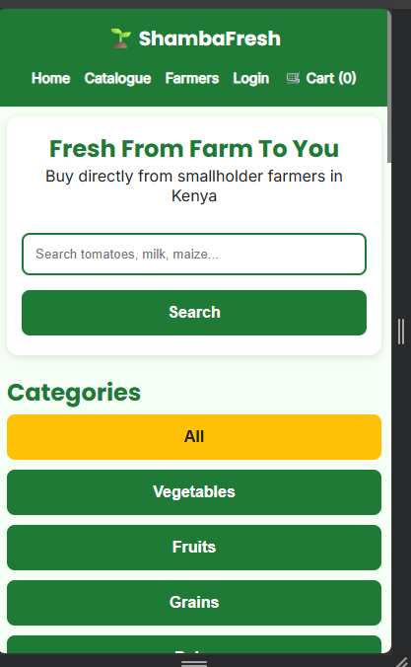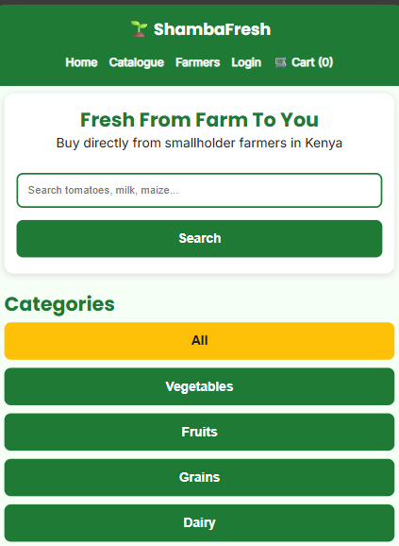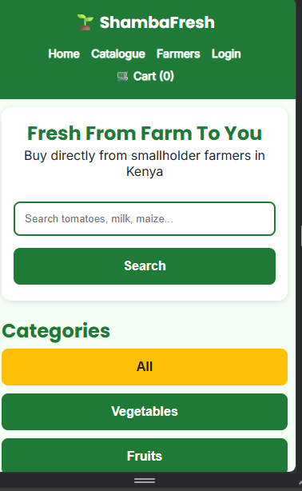

The site uses CSS Grid + Media Queries + Viewport Meta Tag. Layout adapts from 4 columns on desktop to 2 on tablet to 1 on mobile, buttons expand to full width for finger tapping, and text remains readable without zooming.

